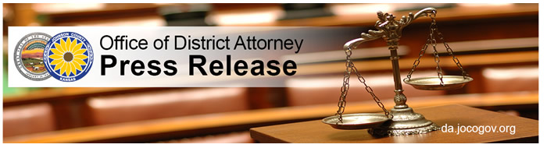

STATE OF KANSAS

Tenth Judicial District

OFFICE OF DISTRICT ATTORNEY

Stephen M. Howe, District Attorney

**JOHNSON COUNTY DISTRICT ATTORNEY STEVE HOWE MAKES THE FOLLOWING ANNOUNCEMENT**

**From: Steve Howe**

**(Olathe, KS)**

***Date: April 13, 2018***

Johnson County District Attorney Steve Howe announces that Lindsey Nichole Thomasson entered a plea of no contest and was found guilty by the Court of the charges of second degree murder and aggravated kidnapping. These charges stem from the death of Presley Porting on February 7, 2017.

Thomasson’s sentencing is scheduled for June 12, 2018.

The case was investigated by the Gardner Police Department and the Johnson County Sheriff’s Department. The case was prosecuted by Assistant District Attorneys Jason Covington and Ryan Walkiewicz.

####